**Mark: _______ / 30**

**HARRISDALE SENIOR HIGH SCHOOL**

SCIENCE DEPARTMENT

Earth and Space Sciences Investigation

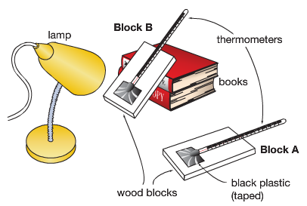**Time allowed:** 1 period to plan investigation, 1 period to conduct investigation, 1 period to complete interpretation and evaluation of results.

**Task:** In groups you will use a model to test whether the angle of sunlight affects the surface temperature on Earth.

You will use black paper stuck to a piece of cardboard to simulate the surface of the Earth. Cardboard A will be laid flat under the heat source (light box), and cardboard B will be propped up on textbooks so it is at an angle. You will measure the temperature of each piece of cardboard every minute for 15 minutes.

**Investigation Title** [1 mark]

**Aim**  [1 Mark]

What are you trying to find out in the investigation?

*[To find out if independent affects dependent]*

To find out if ___________ affects ____________

**Variables** [4 Marks]

|  |  |  |
| --- | --- | --- |
| Independent Variable  (Changed) | Dependent Variable  (Measured) | Controlled Variables  (Kept the same) |
|  |  |  |

**Hypothesis** [1 mark]

A testable statement, linking the independent and dependent variables.

*[If independent changes in this specific way, then dependent changes in this specific way]*

*If __________, then __________*

**Materials** [2 Marks]

List the materials needed to conduct the investigation.



**Method** [3 Marks]

A numbered list of steps describing how to conduct the investigation.

Be specific to your experiment, exactly what steps do you need to take? Someone who just picked up your sheet should be able to replicate it.



**Results Table** [2 marks]

In the space below construct a table to record your results.

*Descriptive Title*

|  |  |  |
| --- | --- | --- |
|  | Temperature (○C) | |
| Time (min) | Block A | Block B |
| 0 |  |  |
| 1 |  |  |
| 2 |  |  |
| 3 |  |  |
| 4 |  |  |
| 5 |  |  |
| 6 |  |  |
| 7 |  |  |
| 8 |  |  |
| 9 |  |  |
| 10 |  |  |
| 11 |  |  |
| 12 |  |  |
| 13 |  |  |
| 14 |  |  |
| 15 |  |  |

**Results Graph** [6 marks]

On graph paper, draw a scatter graph of your results by hand. Include lines of best fit for each piece of cardboard in your investigation and a key.

Hand your graph in to your teacher, or take a photo of your graph and insert it into the word document.

**Interpreting and Evaluating**

1. Use your results to explain how the angle of sunlight affects the temperature. [2 marks]

The block that was angled more directly towards the light __________. The data showed that at the end of 15 minutes, Block A measured ___○C and Block B measured ___ ○C.

1. Which piece of cardboard represents the Earth in summer and which represents Earth in winter? Explain your choice. [4 marks]

Block A represents the Earth in __________ because ___________.

Block B represents the Earth in __________ because ___________.

1. Describe one inaccuracy in the investigation that may have caused unfair results and propose a possible solution. [2 marks]

One possible source of error in this investigation was _______________. This may have impacted the results by ___________.

1. Use your results to explain why hot, tropical climates are found near the equator, and cold, icy climates are found near the poles.[2 Marks]

Hot, tropical climates are found near the equator because ____________. This was represented in this investigation by the angle of Block __.

Cold, icy climates are found near the poles because ____________. This was represented in this investigation by the angle of Block __.